A picture containing clipart

Description generated with very high confidence

Azure 103 Module 4

Hands On - 6

Azure Certification Training

[**support@intellipaat.com**](mailto:support@intellipaat.com)

**+91-7022374614**

**US: 1-800-216-8930(Toll Free)**

**Azure 103 Module 2 , Hands On – 6**

**Connect to Azure File Share Using Windows PC**

**Step 1:** Open the file share in azure portal.

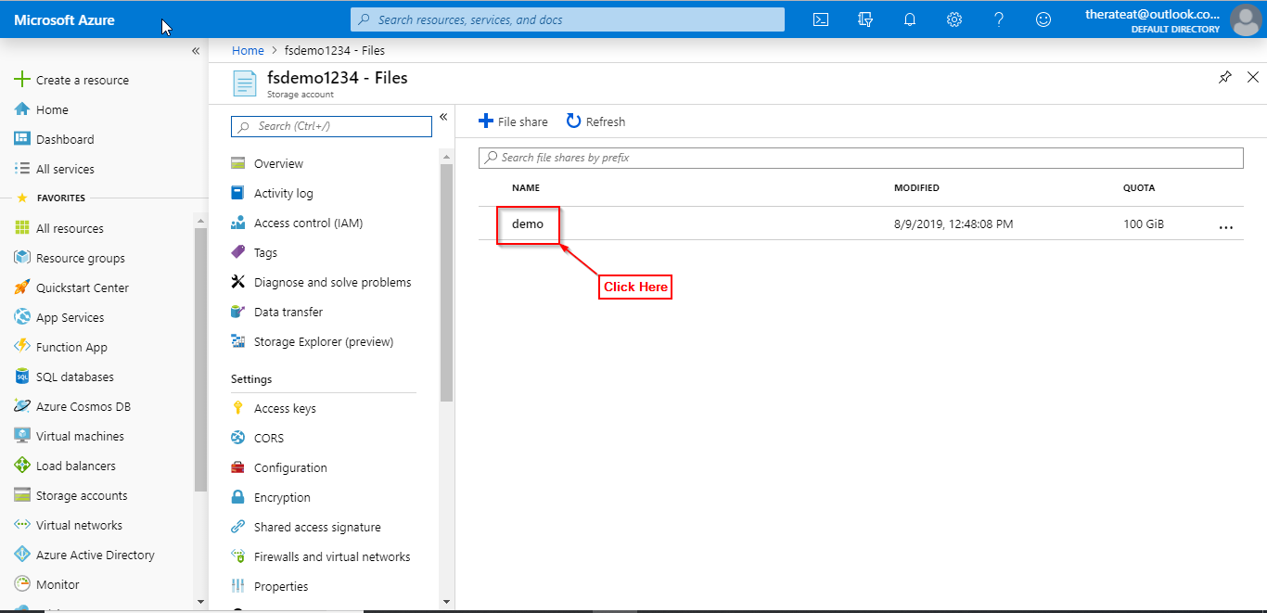

**Step 2:** Click on Connect.

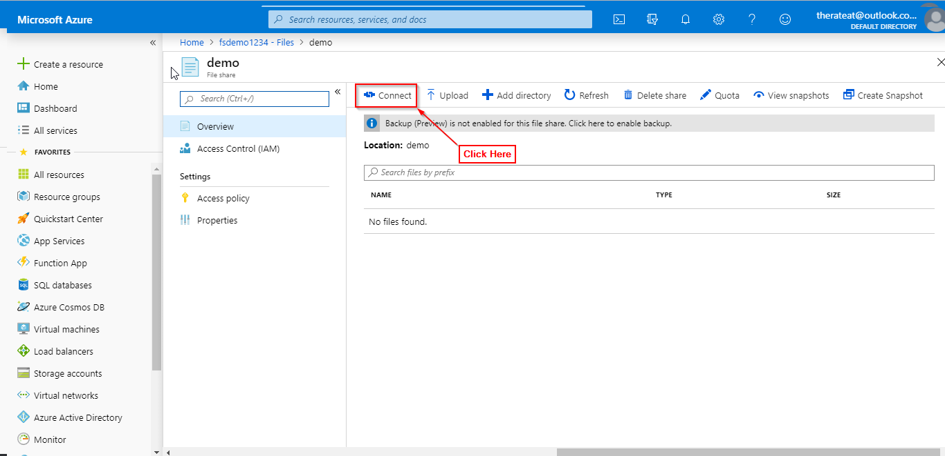

**Step 3:** Under the windows tab click copy the PowerShell command and paste in a safe location.

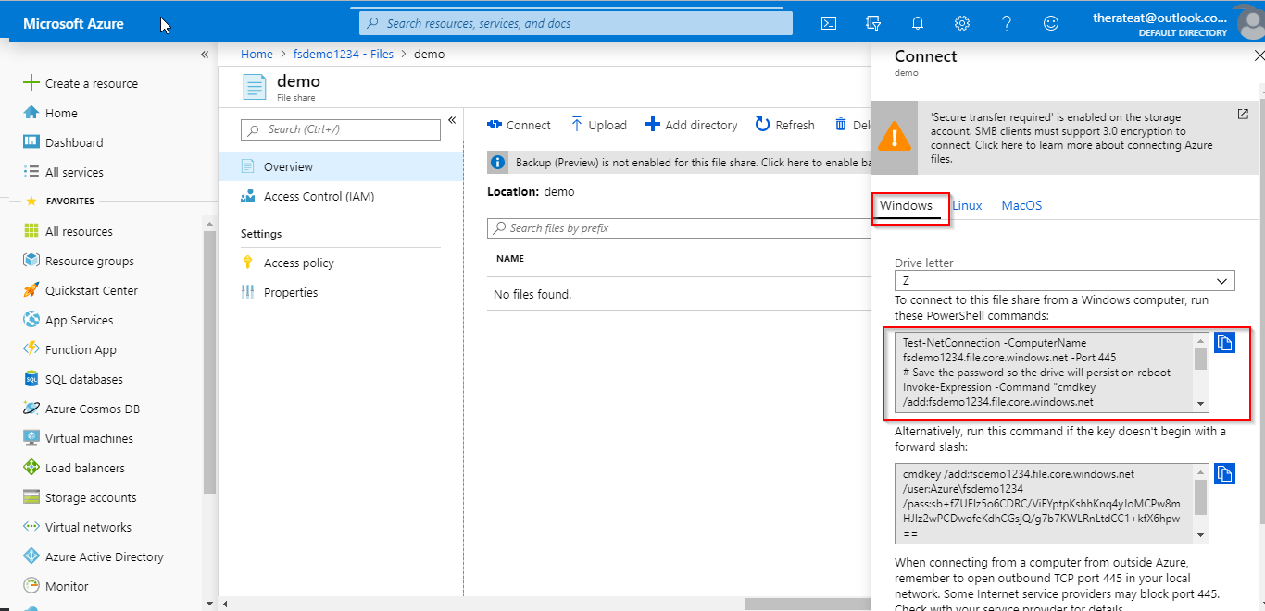

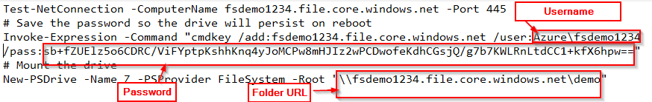

**Step 4:** Open “This PC”.

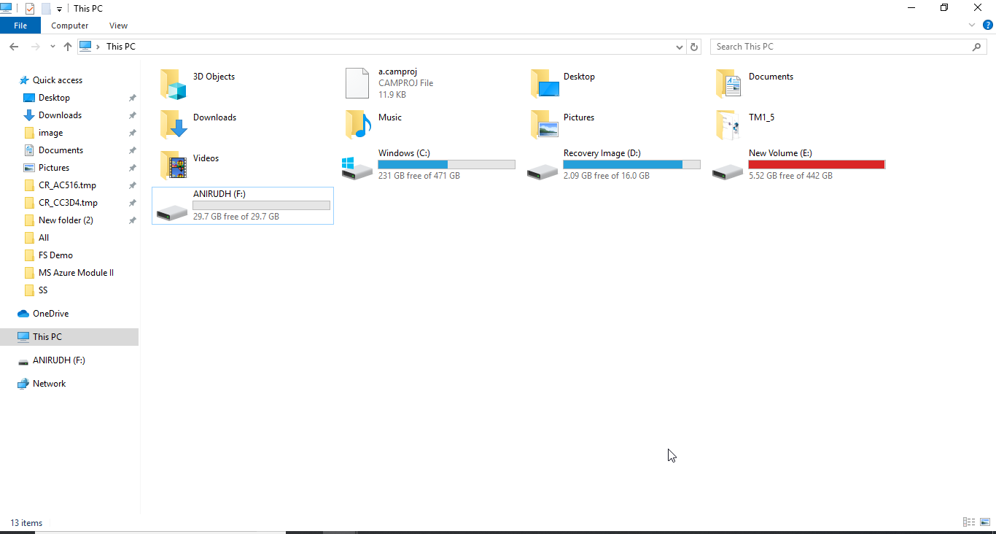

**Step 5:** Right Click on Network and Select Map network drive.

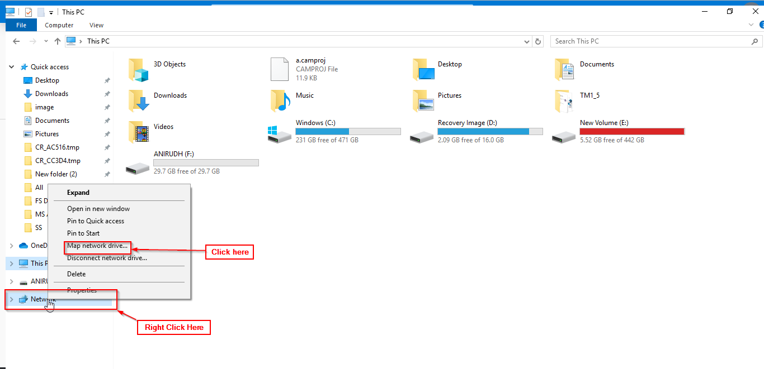

**Step 6:** In the folder section paste the URL copied from the PowerShell command copied in step 3

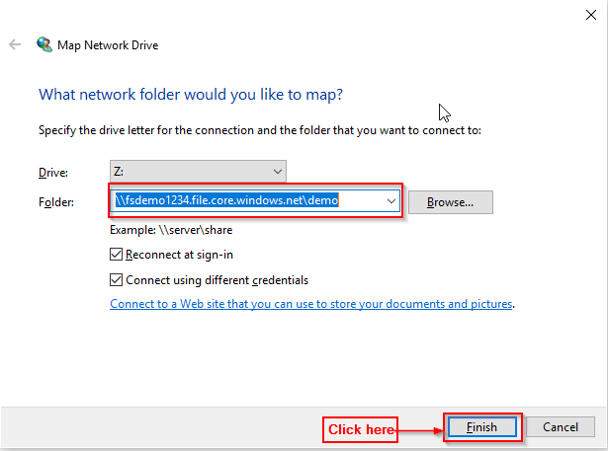

**Step 7:** Enter username and password from the PowerShell command copied in step 3 and click OK.

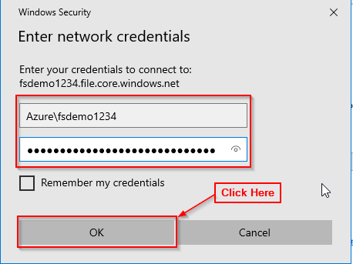

**Step 8:** A folder will open indicating that you have successfully connected to the file share.

